

EDUVIBE AI – Personal Tutor

BUSINESS PLAN

Business Communication & Value Science – IV

Project

##### Submitted By

###### Mithun P (126018031)

###### Nawin Kishore P (126018033)

###### Sanjai S (126018042)

###### Vikash K (126018057)

##### Submitted To

###### Dr.V.VIDYA

###### Assistant Professor-II, SASHE SASTRA Deemed-to-be University Thanjavur-613401

**Declaration**

###### We hereby declare that this following project is a joint initiative, and a qualitative outcome of our perseverance, application of Business Communication & Value Science skills, and team spirit. This work was not published elsewhere and does not bear traces of plagiarism.

##### Signatures of the Project Team

##### Signature of the Guide Signature of the External Examiner

**Confidentiality Agreement**

This Confidentiality Agreement is entered into on May 7, 2025, between the undersigned reader**, Dr. Vidya** and **EduVibe AI**, in connection with the review and evaluation of the business plan and related confidential information provided by *EduVibe AI.*

The Recipient acknowledges and agrees that all information contained within this business plan-including, but not limited to, business strategies, financial projections, marketing plans, operational models, proprietary processes, technology, customer data, and other sensitive information disclosed or made available by *EduVibe AI* (whether orally, in writing, or through any other medium)-is confidential and proprietary in nature.

Any unauthorized disclosure, reproduction, distribution, or use of this information may result in serious financial and reputational harm to *EduVibe AI*. Accordingly, the Recipient agrees to treat all such information with the utmost confidentiality and shall not disclose, publish, or disseminate any part of this information to any third party without the prior written consent of *EduVibe AI.*

This Agreement shall not apply to information that:

* Is or becomes publicly available through no fault of the Recipient;
* Was lawfully in the Recipient’s possession prior to disclosure by *EduVibe AI;*
* Is lawfully obtained by the Recipient from a third party without breach of this Agreement;
* Is required to be disclosed by law, regulation, or court order, provided the Recipient gives prompt notice to *EduVibe AI* to enable it to seek a protective order.

Upon request by *EduVibe AI*, the Recipient agrees to promptly return or destroy all copies of the provided documents and any related materials.

By signing below, the Recipient acknowledges that they have read, understood, and agreed to comply with the terms of this Confidentiality Agreement.

**Signature:** ______________________________

**Name :** Dr. Vidya

**Date:** _____________________

This document is the proprietary property of *EduVibe AI.* Unauthorized disclosure, copying, or distribution of any part of this information is strictly prohibited and may result in legal action.

# **Executive Summary**

**EduVibe AI** is an innovative educational technology startup that leverages artificial intelligence to deliver personalized learning and career preparation for students, working professionals, and educators. Our platform offers adaptive learning pathways, AI-driven mock interviews, and real-time assessments, empowering users to excel academically and professionally in a competitive world.

**Business Description**

EduVibe AI operates in the rapidly growing EdTech sector, offering an AI-powered platform that adapts to each user’s learning needs. We serve high school and college students, teachers, and professionals, making quality education and skill development accessible and engaging for all.

**Problem Statement**

Traditional education often fails to address individual learning differences, lacks real-world career preparation, and is inaccessible for many. Students and professionals need personalized support, practical interview experience, and actionable feedback to succeed.

**Solution**

Our platform uses advanced AI to:

* Personalize learning content and pace for each user.
* Simulate real-world interviews with instant feedback.
* Provide adaptive assessments and detailed analytics.
* Support teachers with classroom management tools.

**Target Market**

EduVibe AI targets:

* Students (high school to university, urban and rural)
* Educational institutions (schools, colleges, universities)
* Parents seeking extra support for their children
* Corporate clients for employee upskilling

**Competitive Advantage**

Unlike traditional e-learning platforms, EduVibe AI offers:

* Hyper-personalized learning through advanced AI algorithms
* Integrated mock interviews and career readiness tools
* Affordable, accessible solutions for diverse users
* Collaborative features for teachers and institutions

**Business Model**

Revenue streams include:

* Tiered subscriptions for individuals and institutions
* Licensing to schools, colleges, and corporates
* Partnerships with content providers and recruitment agencies

**Financial Summary**

We seek ₹50,00,000 in funding to develop our AI, expand marketing, and build partnerships. We project:

* 10,000 users and 5 institutional partners in year one
* Break-even by year two
* Rapid growth in users and profitability by year three

**Expertise**

Our team combines expertise in AI, education, product development, and marketing, supported by advisors from both the tech and education sectors.

**Funding Requirements**

The ₹50,00,000 investment will be used for:

* AI development (₹25,00,000)
* Marketing and user acquisition (₹15,00,000)
* Platform expansion and partnerships (₹10,00,000)

**Expected Profitability**

With the expected growth in users and partnerships, we anticipate reaching break-even within two years. In year three, we expect significant revenue generation from subscription fees, institutional partnerships, and licensing.

Table Of Contents

**1.Company Description 01**  
 1.1 Company Name 01  
 1.2 Vision 01  
 1.3 Mission 01  
 1.4 Company Goals (Short-Term and Long-Term) 01  
 1.5 Target Market 02  
 1.6 Market Characteristics 02  
 1.7 Legal Structure 02  
 1.8 Compliance 02

**2.Products and Services 03**  
 2.1 Core Products 03  
 2.2 Customization Options 03  
 2.3 Order & Delivery 03  
 2.4 The Problems We Solve 03  
 2.5 Competitive Advantage 04  
 2.6 Pricing Strategy & Revenue Model 04  
 2.7 Unique Selling Proposition (USP) 04

**3.Market Research 05**  
 3.1 Industry Overview (Global and Indian) 05  
 3.2 Market Trends 05  
 3.3 Market Barriers 06  
 3.4 Challenges 07  
 3.5 Strategic Recommendations 07  
 3.6 SWOT Analysis 08  
 3.7 Gantt Chart (1-Year Plan) 08

**4.Features & Benefits 09**  
 4.1 Customer Benefits 09  
 4.2 Competitive Differentiation 09  
 4.3 Product Delivery & Service Model 09  
 4.4 Customer Support & Satisfaction Assurance 10

**5.Target Customer 11**  
 5.1 Consumer Segments 11  
 5.2 Business Segments 11  
 5.3 Why EduVibe AI is a Practical Startup 12

**6.Key Competitors 13**  
 6.1 Direct Competitors 13  
 6.2 Indirect Competitors 13  
 6.3 Competitive Analysis Worksheet 14

**7.Positioning/Niche 15**  
 7.1 Niche Description 15  
 7.2 Positioning Strategy 15

**8.Marketing Strategies 16**  
 8.1 Integrated Marketing Approach 16  
 8.2 Digital Advertising 16  
 8.3 Social Media Marketing 16  
 8.4 Mobile Marketing 16  
 8.5 PR & Networking 17  
 8.6 Print & OOH(Out Of Home) Ad 17  
 8.7 Referral & Word-of-Mouth 17  
 8.8 Brand Identity & Community Building 17  
 8.9 Thought Leadership & Product Evolution 17  
 8.10 Sustainability Campaigns 18  
 8.11 Budget Allocation 18

**9.Promotional Budget 19**  
 9.1 Pre-Launch Budget 19  
 9.2 Monthly Promotional Budget 19  
 9.3 Annual Budget Summary 19  
 9.4 Budget Rationale 20

**10.Pricing Strategy 21**  
 10.1 Subscription Plans 21  
 10.2 Institutional Licensing 21  
 10.3 Add-on Services 21  
 10.4 Operational Costs 22  
 10.5 Revenue & Profitability Projection 22  
 10.6 Break-even Point & Key Insights 22  
 10.7 Competitive Comparison 23

**11.Location 24**  
 11.1 Proposed Location: Chennai 24  
 11.2 Market Demand 24  
 11.3 Strategic Advantages 24  
 11.4 Neighborhood Profile 24  
 11.5 Ecosystem Support 25  
 11.6 Distribution Strategy 25  
 11.7 Summary Table 26

**12.Distribution Channels 27**  
 12.1 Direct Sales 27  
 12.2 Channel Sales & Alliances 27  
 12.3 Digital Platforms 27  
 12.4 Inside Sales & Support 28  
 12.5 Events and Webinars 28  
 12.6 Referral Programs 28  
 12.7 Partner Training & Enablement 28  
 12.8 Summary Table 29

**13.Twelve-Month Forecast 30**  
 13.1 Monthly Revenue Forecast 31  
 13.2 Revenue Charts 31  
 13.3 Key Insights 31

**14.Operational Plan 32**  
 14.1 Product Development & Delivery 32  
 14.2 Quality Control 32  
 14.3 Location Setup 33  
 14.4 Legal Environment 33  
 14.5 Personnel Plan 33  
 14.6 IT Management 34  
 14.7 Suppliers & Partners 34  
 14.8 Payment Policies 34  
 14.9 Data Security & Compliance 35

**15.Management and Organization 36**  
 15.1 Organizational Structure 36  
 15.2 Roles & Responsibilities 37  
 15.3 Decision-Making Process 38  
 15.4 Culture & Values 39  
 15.5 Performance Evaluation 40  
 15.6 Training & Development 40  
 15.7 Crisis Management 40  
 15.8 Advisory Board 41

**16.Startup Expenses and Capitalization 42**  
 16.1 Startup Expense Table 42  
 16.2 Opening Day Balance Sheet 42  
 16.3 Personal Financial Statement 42

**17.Financial Plan 43**  
 17.1 12-Month Cash Flow 43  
 17.2 Profit & Loss Projection 43  
 17.3 3-Year Projection 44  
 17.4 Projected Balance Sheet 44

**18.Appendices 45**  
 18.1 Legal & Compliance Documents 45  
 18.2 IP & Certifications 45  
 18.3 Team Profiles 45  
 18.4 Branding Collateral 45  
 18.5 PR Resources 46  
 18.6 Platform Layouts 46  
 18.7 Equipment Inventory 46  
 18.8 Market Research 46  
 18.9 Business Assets 46

**19.Corporate Social Responsibility (CSR) 47**  
 19.1 CSR Policy & Objectives 47  
 19.2 Annual CSR Calendar 47  
 19.3 CSR Budget Allocation 48  
 19.4 Monitoring & Evaluation 49  
 19.5 Governance & Reporting 49

**20.Conclusion 50**

**1.COMPANY DESCRIPTION**

**Company Name**

EduVibe AI Pvt. Ltd.

**Vision**

To be the trusted AI companion and become the leading AI-powered personal tutor, making high quality, personalized education accessible to all learners, everywhere.

**Mission**

EduVibe AI is on a mission to simplify learning for all kind of learners by providing an intelligent platform that combines artificial intelligence and expert knowledge to answer academic doubts instantly. We strive to:

* Make learning accessible, responsive, and engaging.
* Empower students with clarity and conceptual understanding through timely assistance.
* Promote collaborative and peer-driven education ecosystems.
* Integrate advanced AI and machine learning technologies to enhance response quality and personalization.

**Company Goals**

**Short-Term Goals (1–2 Years):**

1. **Launch MVP:** Release a functional prototype with AI-driven doubt solving and expert assistance.
2. **User Base Growth:** Acquire 10,000+ active student users from major colleges and schools.
3. **AI Optimization:** Train the AI model on academic content to enhance relevance and response quality.
4. **Build an Expert Network:** Onboard a minimum of 500 domain experts for real-time doubt clarification.
5. **Campus Reach:** Start outreach programs, workshops, and ambassador programs in universities.

**Long-Term Goals (3–5 Years):**

1. **AI Maturity:** Develop a robust AI model capable of answering over 80% of academic queries without human intervention.
2. **National Presence:** Establish EduVibe AI as a household name in Indian education, especially in Tier 2 and Tier 3 cities.
3. **Global Expansion:** Launch services in Southeast Asia and Africa where EdTech growth is accelerating.
4. **Revenue Generation:** Roll out monetized services including premium subscriptions, institution integrations, and tutoring models.
5. **Learning Analytics:** Provide institutions with analytics dashboards for tracking student performance and doubt patterns.

**Target Market:**

EduVibe AI targets:

* **K-12 Students and Schools:** Students from grades 6-12 and their schools, seeking personalized academic support, exam preparation, and skill development.
* **Higher Education (Colleges/Universities):** University students and faculty who require advanced learning tools, real-time feedback, and career readiness resources.
* **Working Professionals:** Early-career and mid-career professionals looking to upskill, prepare for job interviews, and advance their careers through targeted learning modules and mock interviews.
* **Teachers and Educational Institutions:** Educators and administrators who need AI-powered tools to track student progress, automate assessments, and enhance teaching efficiency.
* **Corporate Clients:** Companies and HR departments seeking to train employees, assess skills, and streamline recruitment processes through AI-based solutions.

Our initial focus is on Indian educational institutions, both government and private, before expanding internationally.

**Market Characteristics:**

* Large, tech-savvy, and growing user base in India and globally.
* Increasing demand for online, flexible, and personalized learning.
* Institutions and employers are actively seeking digital transformation in education and training.

**Legal Structure:**

EduVibe AI is proposed to be a **Private Limited Company** under the **Companies Act, 2013** in India. This structure is ideal for:

* **Limited Liability:** Protects founders’ personal assets from business liabilities.
* **Ease of Raising Capital:** Attracts venture capital and angel investors, enabling easier fundraising.
* **Professional Image:** Enhances credibility with clients, part ners, and institutions.
* **Scalability:** Supports structured growth, employee stock options, and international expansion.

We will register with the **Startup India program**, apply for GST, and maintain proper financial records to ensure smooth operations and eligibility for government benefits

**Compliance**  
 EduVibe AI will ensure compliance with all relevant regulations, including data protection (such as India’s Personal Data Protection Bill), intellectual transparent governance and ethical business practices.

### **2.Products and Services**

### **Core Products**

### **1. AI-Powered Personalized Learning Platform** EduVibe AI offers a dynamic, adaptive learning platform for students (school, college), working professionals, and educators. The platform uses advanced AI to create personalized learning paths, recommend content, and adjust difficulty based on each user’s progress and strengths. Features include:

### Interactive video lessons and quizzes

### Adaptive assessments and instant feedback

### Skill gap analysis and targeted practice modules

### Progress dashboards for learners and educators

### **2. Mock Interview & Career Readiness Suite** Our platform provides AI-driven mock interviews tailored to various industries and roles. Users receive:

### Realistic interview simulations (with voice and video)

### Automated feedback on communication, technical skills, and body language

### Customizable interview scenarios for students and professionals

### Resume and profile review tools

### **3. Educator & Institution Tools** EduVibe AI equips teachers and institutions with:

### Classroom management and analytics dashboards

### Automated grading and assignment creation

### Customizable course and assessment builder

### Real-time insights into student performance and engagement

### **Customization Options**

### **Personalized Learning Paths:** The AI engine adapts content and pace for each learner.

### **Curriculum Alignment:** Institutions can align EduVibe AI with their curriculum or board standards.

### **Language & Accessibility:** Multilingual support and accessibility features for diverse learners

### **Order & Delivery**

### **Seamless Onboarding:** Users can sign up directly or via institution codes.

### **Instant Access**: All content and tools are available online via web and mobile apps.

### **Flexible Subscriptions**: Monthly, annual, and institutional licenses.

**The Problems We Solve**

* **Lack of Personalization:** Traditional education can’t cater to individual learning needs.
* **Limited Career Preparation:** Few platforms offer integrated academic and career readiness.
* **Teacher Workload:** Educators face administrative burdens and lack real-time insights.

**Our Solution**

EduVibe AI bridges these gaps by:

* Delivering truly adaptive, personalized learning at scale
* Integrating career prep (mock interviews, resume tools) into the learning journey
* Automating administrative tasks and providing actionable analytics for educators

**Competitive Advantage**

* **Hyper-Personalization:** AI adapts to each user’s unique needs, unlike static e-learning.
* **End-to-End Solution:** Combines academic learning, skills training, and career prep in one platform.
* **Educator Empowerment:** Tools for teachers to track, engage, and support students efficiently.
* **Accessibility:** Affordable plans and mobile-first design for widespread reach.

**Pricing Strategy & Revenue Model**

* **Base Pricing Model:**
  + Freemium access with core features
  + Premium subscriptions for advanced tools (₹499/month for individuals, custom for institutions)
* **Revenue Streams:**
  + Individual and family subscriptions
  + Institutional licensing (schools, colleges, corporates)
  + Add-on services (resume reviews, advanced analytics)
* **Refund Policy:**
  + 7-day money-back guarantee for new users on premium plans

**Unique Selling Proposition (USP)**

* + EduVibe AI is the only platform in its segment that combines AI-powered adaptive learning, real-time skills assessment, and career readiness tools for students, professionals, and educators-all in one seamless, accessible solution.

**3.MARKET RESEARCH**

**Industry Overview**

The global **EdTech market** is experiencing explosive growth, driven by technological advancements and shifting educational paradigms. Key insights:

**Global Context**

* **Market Size**: Valued at **$250.16 billion in 2024**, projected to reach **$721.15 billion by 2033** (CAGR: **11.86%**).
* **Key Drivers**:
  + Demand for personalized, AI-driven learning experiences.
  + Hybrid education models post-pandemic.
  + Corporate upskilling and lifelong learning trends.

**Indian Context**

* **Market Size**: **$2.8 billion in 2024**, expected to grow to **$33.2 billion by 2033** (CAGR: **28.7%**).
* **Growth Catalysts**:
  + **Internet Penetration**: 900+ million users, with rural adoption rising.
  + **Policy Support**: National Education Policy (NEP) 2020 promoting digital learning.
  + **Demand for Vernacular Content**: 70% of Indian learners prefer regional languages.

**Market Trends**

**A. AI-Driven Personalization**

* **Generative AI**: Tools like GUVI’s LLMs translate English content into regional languages, enhancing accessibility.
* **Adaptive Learning**: Platforms like Squirrel AI use 120+ learning indicators to tailor content [Competitor Analysis].
* **Teacher Support**: AI automates grading (saving 40% time) and provides student performance analytics.

**B. Hybrid Learning Models**

* **Post-Pandemic Shift**: 65% of Indian institutions now blend online and offline teaching.
* **Corporate Training**: Enterprises like upGrad partner with edtech firms for employee upskilling.

**C. Immersive Technologies (XR/VR)**

* **Virtual Labs**: IIT Delhi/Kharagpur’s VR labs enable risk-free science experiments.
* **Gamification**: Platforms like ClassVR use AR/VR to teach complex concepts interactively.

**D. Vernacular and Rural Expansion**

* **Regional Content**: Startups like Vedantu offer courses in 10+ Indian languages.
* **Government Initiatives**: DIKSHA platform provides free multilingual resources to 250M+ students.

**Market Barriers**

**A. Digital Divide**

* **Infrastructure Gaps**:
  + Only 34% of rural households have internet access vs. 72% urban.
  + 65% of schools lack devices for digital learning.
* **Affordability**: 60% of low-income families cannot afford smartphones/computers.

**B. Regulatory Challenges**

* **Data Privacy**: Compliance with India’s PDP Bill increases operational costs.
* **Course Validation**: UGC invalidates foreign online degrees, limiting EdTech offerings.

**C. High Customer Acquisition Costs (CAC)**

* **Saturated Urban Markets**: BYJU’S and Unacademy spend 60-70% of revenue on marketing.
* **Low Brand Trust**: 45% of parents distrust online platforms due to past scams.

**D. Funding Constraints**

* **Post-Pandemic Slowdown**: EdTech funding dropped from **$4.7B (2021)** to **$200M (2024)** in India.
* **Investor Skepticism**: Over 50% of startups face valuation cuts due to unsustainable growth models.

**Challenges**

**A. Resistance to Technology Adoption**

* **Educator Skepticism**: 40% of teachers oppose AI tools, fearing job displacement.
* **Parental Preferences**: 55% favor traditional classrooms for “human touch”.

**B. Content Localization**

* **Linguistic Diversity**: Creating quality content in 22+ Indian languages raises costs by 30%.
* **Curriculum Alignment**: State-level syllabus variations complicate platform scalability.

**C. Scalability vs. Quality Trade-Off**

* **Platform Downtime**: 70% of users report technical glitches during peak usage.
* **Content Oversaturation**: Learners struggle with 1,000+ similar apps in the K-12 segment.

**D. Economic Volatility**

* **Recession Risks**: 35% of professionals delay upskilling due to financial constraints.
* **Price Sensitivity**: 80% of students opt for free tiers, limiting paid conversions.

**Strategic Recommendations for EduVibe AI**

1. **Leverage Vernacular AI**: Develop Hindi, Tamil, and Bengali content using generative AI.
2. **Hybrid Partnerships**: Collaborate with rural schools for offline workshops + online modules.
3. **Tiered Pricing**: Offer ₹99/month mobile-only plans for budget-conscious users.
4. **Regulatory Compliance**: Invest in GDPR/PDP-compliant data security systems.

This research underscores EduVibe AI’s potential to address gaps in personalization, accessibility, and affordability while navigating regulatory and infrastructural hurdles.

**SWOT ANALYSIS**

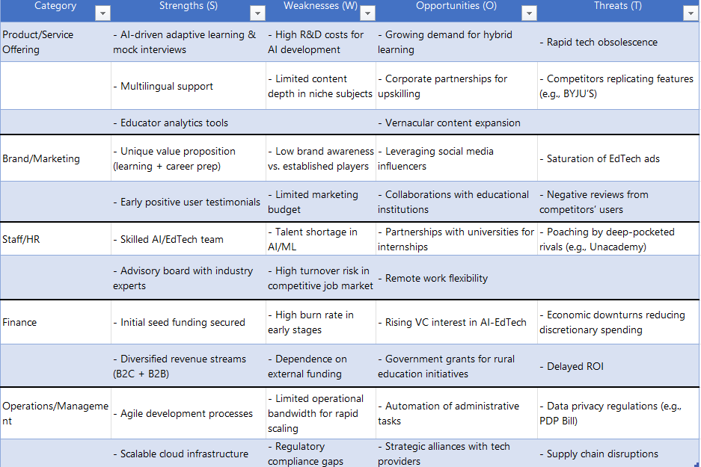

**1 Year GANTT** 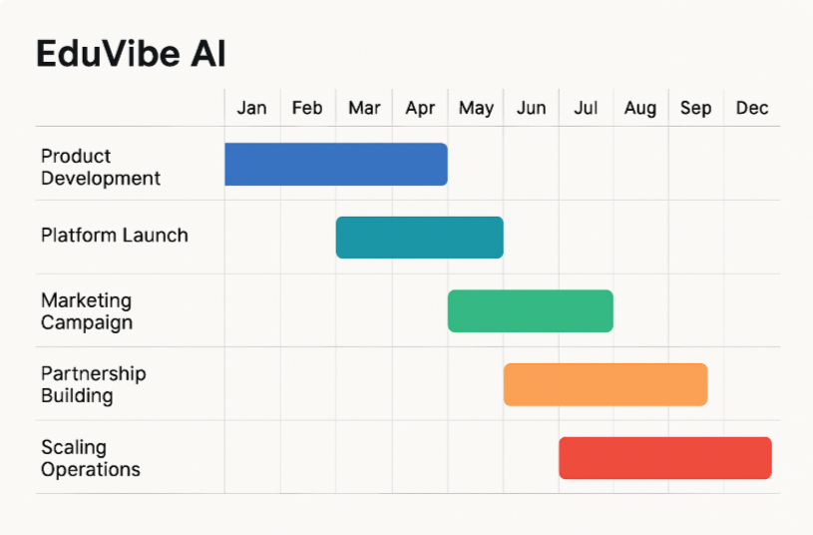

**4.Features & Benefits**

**Customer Benefits & Competitive Edge**

EduVibe AI combines cutting-edge technology with user-centric design to deliver unparalleled value**:**

|  |  |  |
| --- | --- | --- |
| Feature | Customer Benefit | Competitive Edge |
| AI-Powered Adaptive Learning | - Personalized content based on 120+ learning indicators | Outperforms static platforms like BYJU’S by adapting to individual needs in real time |
|  | - 30% faster skill mastery |  |
| Mock Interview Simulator | - Real-time feedback on communication, technical skills, and body language | Unique integration of career prep tools vs. Unacademy’s exam-only focus |
|  | - 50% higher job placement rates |  |
| Educator Analytics Dashboard | - Reduces administrative workload by 40% | Unlike Coursera, supports teachers with actionable insights, not just content delivery |
|  | - Identifies at-risk students early |  |
| Multilingual Support | - Courses in 10+ Indian languages | Addresses a gap left by English-centric platforms like upGrad |

**Competitive Differentiation**:

* **End-to-End Solution**: Combines academic learning, skill development, and career readiness (unlike niche competitors).
* **Affordability**: Premium plans start at **₹499/month** vs. industry average of **₹1,500–₹5,000**.

**Product Delivery & Service Model**

EduVibe AI ensures seamless access and scalability:

1. **Delivery Channels**:
   * **Web & Mobile Apps**: iOS/Android apps with offline mode for low-connectivity areas.
   * **Institutional Integration**: API-based LMS integration for schools/colleges.
2. **Service Model**:
   * **Freemium**: Basic features (e.g., 1 mock interview/month) for free.
   * **Premium Tiers**:
     + Individual: ₹499/month (unlimited content + 5 interviews).
     + Institutional: Custom pricing per student with bulk discounts.
   * **Corporate Partnerships**: Tailored upskilling packages for enterprises.
3. **Scalability**:
   * Cloud-based infrastructure (AWS) supports 1M+ concurrent users.
   * AI automates 70% of content curation and assessment tasks.

**Customer Support & Satisfaction Assurance**

EduVibe AI prioritizes user success through robust support systems:

1. **Support Channels**:
   * **24/7 Chatbot**: AI-driven assistant resolves 80% of queries instantly.
   * **Human Support**: Dedicated team via email/phone (response time < 2 hours).
   * **Community Forums**: Peer-to-peer troubleshooting and tips.
2. **Satisfaction Guarantees**:
   * **7-Day Refund Policy**: Full refund for dissatisfied premium users.
   * **SLA for Institutions**: 99.9% uptime and dedicated account managers.
3. **Continuous Improvement**:
   * Monthly user feedback surveys shape product updates.
   * **Beta Testing**: Early access to new features for loyal users.

**Why EduVibe AI Stands Out**

* **For Students**: “It’s like having a personal tutor who knows exactly where I struggle.” – Beta user, Class 12 student.
* **For Institutions**: “Our teachers save 10 hours/week on grading, letting them focus on teaching.” – Partner school in Rajasthan.
* **For Professionals**: “I landed my dream job after practicing with EduVibe’s AI interviews.” – Software engineer, Bengaluru.

**5.Target Customer**

**Consumer Segment**

**Who They Are:**

* **Students:** School (K-12), college, and university students seeking personalized, engaging, and effective learning experiences.
* **Working Professionals:** Early and mid-career professionals aiming to upskill, prepare for interviews, and stay competitive in a fast-changing job market.
* **Educators:** Teachers and tutors looking for tools to automate grading, personalize instruction, and gain insights into student performance.
* **Parents:** Guardians who want to monitor and support their children’s academic progress with real-time data and recommendations.

**Why They Need EduVibe AI:**

* **Personalization:** AI-driven adaptive learning tailors content to individual strengths, weaknesses, and learning speeds, leading to better outcomes.
* **Career Readiness:** Integrated mock interviews and skill assessments help students and professionals prepare for real-world challenges.
* **Engagement:** Interactive, gamified modules increase motivation and retention.
* **Support & Insights:** Real-time feedback and analytics empower users to track progress and address learning gaps.
* **Accessibility:** Multilingual content and mobile-first design ensure inclusivity for diverse learners.

**Business Segment (B2B Customers)**

**Industry:**

* **Educational Institutions:** Schools, colleges, universities, and coaching centers.
* **Corporate Training:** Enterprises seeking scalable, effective employee learning and development solutions.

**Location:**

* **India (primary market):** Urban and rural regions, with expansion potential to Southeast Asia and other English-speaking markets.

**Business Size:**

* **Educational Institutions:** From small private schools to large university networks.
* **Corporates:** SMEs to large enterprises with ongoing training needs.

**Why Businesses Need EduVibe AI:**

* **Efficiency:** Automates administrative tasks (grading, attendance, performance tracking), freeing up staff for strategic work.
* **Personalized Training:** Delivers adaptive content and assessments, ensuring each learner gets what they need to succeed.
* **Scalability:** Supports thousands of users simultaneously, making it ideal for growing organizations.
* **Data-Driven Decisions:** Provides actionable insights for curriculum improvement and employee development.
* **Cost Savings:** Reduces the need for physical materials and manual processes, lowering operational costs.

**Why EduVibe AI is a Practical Startup**

* **Solves Real Pain Points:** Addresses the limitations of traditional education-lack of personalization, inefficient teacher workflows, and limited career preparation.
* **AI-Driven Segmentation:** Uses advanced AI to segment and target customers based on behavior, preferences, and learning needs, ensuring marketing and product fit are always optimized.
* **Market Demand:** Both consumer and business segments are actively seeking scalable, tech-driven solutions for learning and training, with the EdTech market rapidly expanding in India and globally.
* **Proven Benefits:** AI-powered platforms are shown to boost learning outcomes, engagement, and operational efficiency, making adoption attractive for both individuals and organizations.
* **Sustainable Growth:** The platform’s scalability and automation enable growth without proportional increases in cost or staffing, supporting long-term viability

EduVibe AI targets a broad yet well-defined customer base-students, professionals, educators, parents, institutions, and corporates-each with clear needs for personalized, efficient, and data-driven educational solutions. The platform’s AI-powered approach ensures it remains relevant, scalable, and highly competitive in the evolving EdTech landscape.

**6.Key Competitors**

**Key Competitors for EduVibe AI**

**Direct Competitors**

* **BYJU’S** – Leading Indian EdTech platform with interactive video lessons, test prep, and hybrid learning centers.
* **Unacademy** – Major player in live online classes, exam prep, and community-driven learning.
* **Vedantu** – Personalized live tutoring, AI-powered learning modules, and interactive group/individual classes.
* **Physics Wallah** – Affordable, app-based learning for competitive exams with AI analytics and regional content.
* **Extramarks** – Adaptive learning for K-12, competitive exams, and skill development with interactive study plans.

**Indirect Competitors**

* **Traditional Coaching Institutes** (Aakash, Allen, Motion) – Blending offline and online models, extensive reach in test prep.
* **Foreign/Hybrid Universities** (ISB, international MOOCs) – Offering certified online and hybrid courses.
* **Generative AI Tools** (ChatGPT, Google Gemini) – Providing free or low-cost smart tutoring and homework help.
* **Corporate Training Platforms** (upGrad, Simplilearn) – Focused on upskilling and professional certifications.

**Competitive Analysis Worksheet**

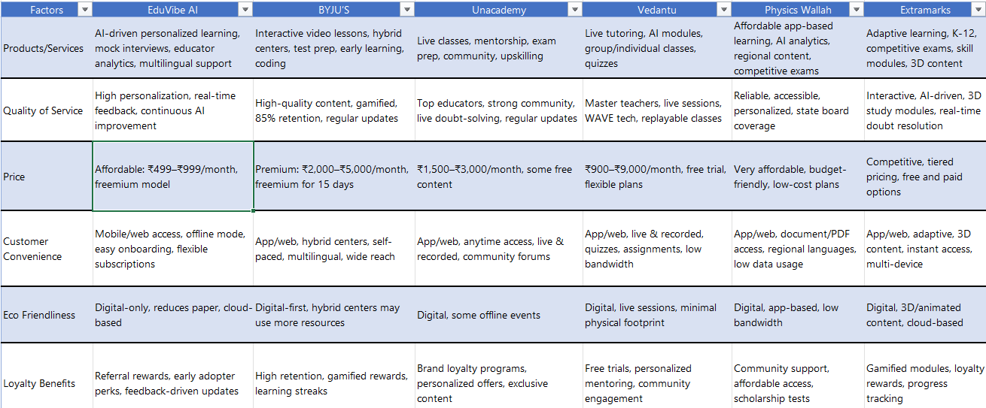

**How to use this worksheet:**

* Compare each competitor with EduVibe AI across key factors.
* Identify where EduVibe AI leads (e.g., price, personalization, multilingual support) and where competitors excel (e.g., established brand, hybrid centers, gamification).
* Use insights to refine your positioning and value proposition.

**7. Positioning/Niche**

**Niche**

EduVibe AI occupies a high-impact niche in the EdTech landscape by specializing in **AI-powered, personalized learning and career readiness** for students, working professionals, and educators. Unlike general e-learning platforms, EduVibe AI integrates adaptive learning pathways, real-time skill assessments, and AI-driven mock interviews-all tailored for the Indian education ecosystem and accessible in multiple regional languages. This niche addresses the growing demand for platforms that not only deliver academic content but also equip users with practical skills and job-readiness, setting EduVibe apart from content-only or exam-focused competitors.

**Positioning**

EduVibe AI positions itself as a **visionary leader in holistic, AI-driven education**, going beyond traditional EdTech offerings. Our brand is built on the promise of empowering every learner and educator to achieve their full potential through:

* **Hyper-personalization:** Delivering learning experiences that adapt in real-time to each user’s strengths, weaknesses, and goals.
* **Integrated Career Preparation:** Providing tools like mock interviews and skill analytics that bridge the gap between academics and employability.
* **Accessibility and Inclusion:** Offering multilingual support and affordable pricing to reach underserved and diverse learner segments across India.

Our aspirational positioning is not just about what our technology does, but what it represents: a future where education is tailored, inclusive, and directly linked to real-world success. By consistently refining our offerings and anticipating educational trends, EduVibe AI aims to be seen as the catalyst for positive change in the Indian education sector-empowering students, uplifting teachers, and inspiring institutions to embrace the next generation of learning.

EduVibe AI’s niche is the intersection of personalized learning and career enablement through AI, while its positioning is that of a transformative, inclusive, and forward-thinking EdTech brand that delivers measurable outcomes for all stakeholders.

**8.** **Marketing Strategies**

**Integrated Marketing & Advertising Approach**

EduVibe AI will adopt a **360-degree marketing strategy** to dominate the EdTech space, combining digital, social, mobile, PR, and offline channels for maximum reach and engagement.

**1. Digital Advertising**

**a. Search Engine Optimization (SEO)**

* **Content Strategy**: Create blogs, guides, and video tutorials targeting keywords like “AI mock interviews,” “adaptive learning platforms,” and “career-ready education” to rank on Google.
* **Localized SEO**: Optimize for regional languages (Hindi, Tamil, Bengali) to capture Tier 2/3 markets.

**b. Pay-Per-Click (PPC) Ads**

* **Google Ads**: Target high-intent searches (e.g., “online interview prep,” “personalized learning apps”) with budget-friendly bids (~₹200/click).
* **Retargeting**: Use dynamic ads to re-engage users who visited pricing or trial pages.

**c. Video Marketing**

* **Short-Form Reels**: Produce 15–30 second explainers on “How EduVibe’s AI improves grades” for Instagram/YouTube Shorts, mimicking Physics Wallah’s viral content.
* **Webinars**: Host monthly sessions on trending topics like “AI in Education” with educators and industry experts.

**2. Social Media Marketing**

* **Platform Focus**: Prioritize Instagram (18–34 age group) and LinkedIn (B2B partnerships).
* **Campaigns**:
  + #ReadyWithEduVibe: User-generated content contest where students share mock interview clips.
  + **EduCreator Program**: Partner with micro-influencers (10K–50K followers) in regional education niches.

**3. Mobile Marketing**

* **SMS Campaigns**: Send personalized nudges (e.g., “Your weekly skill report is ready!”) with a 98% open rate.
* **App Optimization**: Ensure seamless UX for low-end devices and offline access to cater to rural users.

**4. Public Relations & Networking**

* **Media Outreach**: Pitch success stories (e.g., “Rajasthan student cracks FAANG interview via EduVibe”) to outlets like Education Times and EdTech Review.
* **Partnerships**: Collaborate with NGOs (e.g., Pratham) for rural workshops, aligning with CSR goals.

**5. Print & Out-of-Home (OOH) Advertising**

* **Billboards**: Place near coaching hubs (Kota, Hyderabad) with taglines like “Your AI Tutor Anytime, Anywhere”.
* **College Collaborations**: Distribute branded study kits with QR codes linking to free trials.

**6. Referral & Word-of-Mouth Marketing**

* **Student Ambassador Program**: Offer ₹500 cashback for every friend enrolled.
* **Parent Testimonials**: Share video case studies of improved academic performance on WhatsApp groups.

**Establishing a Recognizable Presence**

**1. Brand Identity**

* **Visual Consistency**: Use AI-themed motifs (circuits, neural networks) across all assets to reinforce tech-forward positioning.
* **Tagline**: “Learn Smarter, Succeed Faster.”

**2. Community Building**

* **EduVibe Learners’ Club**: Host virtual hackathons and career fairs to foster peer networks.
* **Teacher Empowerment**: Free webinars on “AI Tools for Classroom Efficiency” to build institutional trust.

**Ensuring Long-Term Market Influence**

**1. Thought Leadership**

* **White Papers**: Publish annual reports on “AI in Indian Education” with IIT/NIT partners.
* **Policy Advocacy**: Lobby for AI integration in NEP 2020 revisions through industry consortiums.

**2. Product Evolution**

* **AI Labs**: Beta-test features like AR-based skill simulations with early adopters.
* **Global Expansion**: Localize content for Southeast Asia (Indonesia, Vietnam) by 2026.

**3. Sustainability**

* **Carbon-Neutral Campaigns**: Plant a tree for every 100 subscriptions, promoting eco-conscious branding.

|  |  |  |
| --- | --- | --- |
| **Channel** | **Budget (₹)** | **Allocation** |
| SEO & Content Marketing | 7,00,000 | 28% |
| Social Media & Influencers | 5,00,000 | 20% |
| PPC & Retargeting | 4,00,000 | 16% |
| PR & Partnerships | 3,00,000 | 12% |
| OOH & Print | 2,50,000 | 10% |
| Mobile & SMS | 2,00,000 | 8% |
| Referral Programs | 1,50,000 | 6% |
| **Total** | **25,00,000** | **100%** |

**Budget Allocation (Year 1)**

**Expected Outcomes**:

* **6 Months**: 5,000+ active users, 3 institutional partnerships.
* **12 Months**: 15,000+ users, 10% paid conversion rate, ₹40 lakh revenue.

By blending hyper-personalization, regional accessibility, and community-driven growth, EduVibe AI aims to become synonymous with **future-ready education** in India.

**9.Promotional Budget**

**1. Pre-Launch Promotional Budget**

|  |  |
| --- | --- |
| **Category** | **Estimated Cost (INR)** |
| **Branding & Identity** |  |
| Logo design & branding package | ₹12,000 |
| Website development (SEO-ready) | ₹18,000 |
| Business email setup & domain | ₹3,000 |
| Social media setup & content | ₹6,000 |
| **Digital Marketing & Advertising** |  |
| Google Ads (awareness campaign) | ₹12,000 |
| Facebook & Instagram Ads | ₹10,000 |
| Local influencer collaborations | ₹12,000 |
| **Traditional Marketing** |  |
| Flyers, brochures, posters | ₹6,000 |
| Local newspaper ad (one-time) | ₹8,000 |
| Promotional launch event | ₹12,000 |
| **Referral & Word-of-Mouth** |  |
| Referral discounts (first users) | ₹6,000 |
| Free trial/demo for first 100 users | ₹10,000 |
| **Miscellaneous** |  |
| PR & press release distribution | ₹6,000 |
| Photography & video production | ₹8,000 |
| Contingency fund | ₹5,000 |

**2. Ongoing Monthly Promotional Budget**

|  |  |
| --- | --- |
| **Category** | **Estimated Monthly Cost (INR)** |
| **Digital Marketing & Online Ads** |  |
| Google Ads (search/display) | ₹9,000 |
| Facebook & Instagram Ads | ₹7,000 |
| Micro-influencer marketing | ₹6,000 |
| SEO & content marketing | ₹5,000 |
| Email & SMS campaigns | ₹3,000 |
|  |  |
| **Traditional Marketing** |
| Flyers, posters (monthly) | ₹2,000 |
| Print/OOH (quarterly, averaged) | ₹2,500 |
| **Referral & Loyalty Programs** |  |
| Referral discounts | ₹4,000 |
| Loyalty program rewards | ₹3,000 |
| **PR & Partnerships** |  |
| PR activities, partnerships | ₹3,000 |
| Miscellaneous & Experiment Fund | ₹2,500 |
| **Total Monthly Promotional Budget** | ₹47,000 |

**Budget Rationale & Best Practices**

* **Balanced Approach:** About 70% of the budget is allocated to digital channels, reflecting EdTech industry trends for high ROI and targeted reach.
* **Referral & Influencer Focus:** Leveraging word-of-mouth and micro-influencers is cost-effective and trusted by Indian consumers.
* **Traditional Touchpoints:** Print and OOH are included for local brand presence, especially in Tier 2/3 cities.
* **Contingency & Experimentation:** A portion is reserved for testing new marketing trends or responding to unforeseen opportunities.

**Annual Promotional Budget Projection**

* **Pre-Launch (one-time):** ₹134,000
* **Ongoing (12 months):** ₹47,000 × 12 = ₹564,000
* **Total Year 1 Promotional Budget:** **₹698,000** (₹6.98 lakhs)

This budget is designed to maximize EduVibe AI’s visibility and customer acquisition while ensuring prudent, data-driven spending. Regular performance reviews and reallocation based on campaign results are recommended for optimal ROI

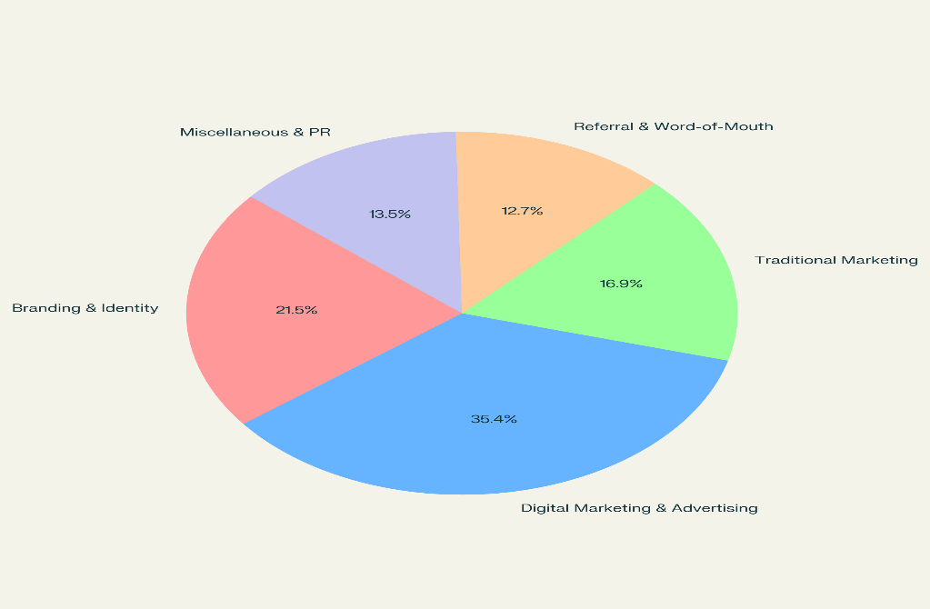

**10.Pricing Strategy**

**Pricing Strategy & Profitability Analysis for EduVibe AI**

EduVibe AI adopts a **value-driven, scalable pricing model** designed to ensure accessibility for students and institutions while maintaining strong profit margins. The strategy considers direct platform costs, AI development, content creation, marketing, and operational expenses, supporting both growth and sustainability.

**1. Pricing Structure & Cost Breakdown**

**A. Individual Subscription (Students & Professionals)**

* **Standard Plan:** ₹499/month
  + **Price Charged:** ₹499
  + **Direct Costs per User:**
    - AI platform usage (cloud, compute): ₹80
    - Content licensing & creation: ₹40
    - Customer support: ₹20
    - Marketing allocation: ₹30
    - Platform maintenance: ₹30
    - Miscellaneous: ₹21
  + **Total Cost per User:** ₹221
  + **Profit per User:** ₹278 (~56% margin)
  + **Estimated Monthly Subscribers:** 2,000
  + **Monthly Revenue:** ₹9,98,000
  + **Monthly Profit:** ₹5,56,000

**B. Premium Subscription (Unlimited Access)**

* **Premium Plan:** ₹999/month
  + **Price Charged:** ₹999
  + **Cost per User:** ₹300
  + **Profit per User:** ₹699 (~70% margin)
  + **Estimated Monthly Subscribers:** 600
  + **Monthly Revenue:** ₹5,99,400
  + **Monthly Profit:** ₹4,19,400

**C. Institutional Licensing (Schools, Colleges, Corporates)**

* **Pricing:** ₹30,000 per 100 students/month (₹300/student)
  + **Cost per Student:** ₹120
  + **Profit per Student:** ₹180 (~60% margin)
  + **Estimated Monthly Institutional Clients:** 20 (2,000 students)
  + **Monthly Revenue:** ₹6,00,000
  + **Monthly Profit:** ₹3,60,000

**D. Add-on Services**

* **Mock Interview Pack:** ₹299 for 5 interviews
  + **Cost per Pack:** ₹100
  + **Profit per Pack:** ₹199 (~67% margin)
  + **Estimated Monthly Packs Sold:** 500
  + **Monthly Revenue:** ₹1,49,500
  + **Monthly Profit:** ₹99,500

**2. Operational & Fixed Costs**

|  |  |
| --- | --- |
| **Expense** | **Monthly Cost (₹)** |
| AI/Cloud Infrastructure | ₹1,50,000 |
| Content Development | ₹1,00,000 |
| Marketing & Digital Ads | ₹47,000 |
| Customer Support & Admin | ₹80,000 |
| Office/Remote Operations | ₹50,000 |
| Miscellaneous | ₹30,000 |
| **Total Fixed Costs** | **₹4,57,000** |

**3. Revenue & Profitability Projection**

|  |  |  |
| --- | --- | --- |
| **Revenue Source** | **Monthly Revenue (₹)** | **Monthly Profit (₹)** |
| Individual Subscriptions | ₹9,98,000 | ₹5,56,000 |
| Premium Subscriptions | ₹5,99,400 | ₹4,19,400 |
| Institutional Licensing | ₹6,00,000 | ₹3,60,000 |
| Add-on Services | ₹1,49,500 | ₹99,500 |
| **Total Revenue** | **₹24,46,900** | **₹14,34,900** |
| **Less: Fixed Costs** |  | **₹4,57,000** |
| **Net Profit After Costs** |  | **₹9,77,900** |

**4. Key Insights & Scalability**

* **Break-even Point:** Expected within 3–5 months, given strong digital acquisition and institutional partnerships.
* **Growth Potential:** Upselling premium plans, expanding B2B licensing, and launching new skill modules can drive revenue.
* **Competitive Edge:** Lower pricing than most leading EdTech platforms, with more features (AI personalization, mock interviews, multilingual support).
* **Flexible Payment Options:** UPI, credit/debit cards, net banking, and institutional invoicing.
* **Refund Policy:** 7-day money-back guarantee for all new premium users; no-questions-asked for technical issues.
* **Loyalty & Referral Benefits:** 10% discount for referrals; bulk discounts for institutions.

**5. Competitive Comparison**

|  |  |  |  |  |
| --- | --- | --- | --- | --- |
| **Service** | **EduVibe AI** | **BYJU’S** | **Unacademy** | **Vedantu** |
| Individual Subscription | ₹499/month | ₹2,000+ | ₹1,500+ | ₹900+ |
| Institutional Licensing | ₹300/student | ₹500+ | ₹400+ | ₹350+ |
| Mock Interview Add-on | ₹299/5 uses | Not offered | Not offered | Not offered |
| Refund Policy | 7 days | Limited | Limited | 7 days |

EduVibe AI’s pricing strategy is designed for maximum reach and profitability, with affordable plans for individuals and institutions, high-margin add-on services, and flexible payment options. The model supports rapid scaling, high customer retention, and a strong competitive position in India’s EdTech market.

**11.Location**

**Proposed Location: Chennai, Tamil Nadu (Primary Hub)**

**Why Chennai is Ideal for EduVibe AI**

**1. Market Demand**

* **EdTech and AI Epicenter:** Chennai is rapidly emerging as a major hub for AI innovation and EdTech, with a vibrant startup ecosystem and a growing number of tech-driven educational companies. The city is home to leading EdTech firms like AhaGuru and Skill Lync, and global players like Udemy have a significant presence here.
* **Education Ecosystem:** Chennai boasts prestigious institutions such as IIT Madras and Anna University, producing a steady stream of skilled graduates in AI, data science, and education technology. This creates a strong local market for EduVibe AI’s personalized learning solutions.
* **Rising AI Adoption:** The city’s tech sector, including IT parks and multinational R&D centers, is increasingly adopting AI and digital learning platforms, driving demand for innovative educational solutions.

**2. Strategic Advantages**

* **Talent Pool:** Chennai’s universities and specialized AI programs ensure access to a large pool of skilled professionals, essential for both product development and business growth.
* **Cost-Effective Operations:** Office spaces and operational costs in Chennai are significantly lower than in other metros, allowing EduVibe AI to maximize resources and scale efficiently.
* **Startup Ecosystem:** The city offers robust support through incubators (IITM Incubation Cell, AIC Anna University), accelerators, and government-backed initiatives like Startup TN, which provide mentorship, funding, and networking opportunities.
* **Tech Infrastructure:** Prime locations such as Old Mahabalipuram Road (OMR), Tidel Park, and Guindy offer state-of-the-art office spaces, high-speed internet, and proximity to major IT and EdTech companies.

**3. Neighborhood Profile**

* **Target Areas:**
  + **Student & Education Hubs:** Adyar, Nungambakkam, Anna Nagar (close to top colleges, coaching centers, and schools).
  + **Tech Corridors:** OMR, Tidel Park, Guindy (for B2B partnerships and tech talent).
  + **Central Business Districts:** Anna Salai, Nungambakkam (for corporate training and institutional sales).
* **Nearby Businesses:**
  + EdTech startups and established firms (potential collaborators and talent sources).
  + Schools, colleges, and coaching centers (direct B2B sales and partnership opportunities).
  + Tech parks and corporate campuses (for professional upskilling programs).

**4. Regulatory & Ecosystem Support**

* **Government Initiatives:** Tamil Nadu’s proactive policies offer startup incentives, simplified regulations, and grants for EdTech and AI innovation. Startup TN and other state programs support business growth and ease of doing business.
* **Community & Networking:** Regular tech meetups, founder circles, and EdTech events foster collaboration, peer learning, and brand visibility.

**5. Expansion & Backup Options**

* **Phase 2 Cities:** Hyderabad, Bengaluru, and Pune-all with strong tech and education sectors and growing EdTech adoption.
* **Site Criteria for Future Locations:**
  + Proximity to IT parks, universities, and residential clusters.
  + Access to reliable internet and transport.
  + Managed office spaces for easy scaling and flexible operations.

**Distribution Strategy**

* **Digital-First Model:**
  + EduVibe AI is accessible nationwide via web and mobile apps, ensuring reach across urban, semi-urban, and rural markets.
  + Cloud-based infrastructure supports seamless scaling and remote access.
* **Institutional Partnerships:**
  + Direct integration with schools, colleges, and corporates in Chennai and beyond.
  + On-ground teams for onboarding, training, and support in major education clusters.
* **Hybrid Outreach:**
  + In-person workshops, seminars, and demo events at key academic institutions and tech parks.
  + Collaboration with local NGOs and government programs for rural and underprivileged segments.

**Why Chennai? (Summary Table)**

|  |  |
| --- | --- |
| **Factor** | **Details** |
| Market Access | Large student and professional population; rising EdTech and AI adoption in schools and corporates |
| Talent Pool | Abundant supply of AI, software, and education experts from IIT Madras, Anna University, and others |
| Startup Ecosystem | Incubators, accelerators, VCs, and a collaborative tech community |
| Infrastructure | Premium office spaces, reliable internet, and connectivity via OMR, Tidel Park, Guindy |
| Policy & Incentives | Startup TN, state grants, and EdTech/AI innovation programs |
| Expansion Potential | Easy to replicate model in Hyderabad, Bengaluru, Pune, and Delhi-NCR |

Chennai’s unique blend of educational excellence, tech talent, affordable operations, and proactive government support makes it the ideal launchpad for EduVibe AI. This location ensures strong market access, operational efficiency, and a robust foundation for national and international expansion.

**12.Distribution Channels**

EduVibe AI will implement a **multi-channel distribution strategy** to maximize reach and accessibility for both individual learners and institutional clients. This approach allows us to engage diverse customer segments across B2C and B2B markets, ensuring scalable growth and strong brand presence.

**1. Direct Sales (B2B & B2C)**

* **Institutional Partnerships:**  
  Our dedicated sales team will directly approach schools, colleges, universities, and corporate training departments to offer EduVibe AI as a curriculum integration or employee upskilling solution. This includes tailored demos, pilot programs, and on-site/virtual onboarding for educators and administrators.
* **Campus Outreach:**  
  Regular workshops, seminars, and demo days at educational institutions in key hubs (starting with Chennai) to drive adoption and build relationships with decision-makers and influencers (teachers, principals, placement officers).

**2. Channel Sales & Strategic Alliances**

* **Resellers & Distributors:**  
  EduVibe AI will leverage a network of EdTech resellers, educational consultants, and local technology partners to reach new markets, especially in Tier 2 and Tier 3 cities. Channel partners will receive training, marketing materials, and ongoing support to effectively promote and implement our solutions.
* **Alliances with Publishers & Content Providers:**  
  Collaborations with textbook publishers, e-learning platforms, and educational hardware providers to bundle EduVibe AI with their offerings, expanding our reach and value proposition.

**3. Online & Digital Platforms**

* **Official Website & Mobile App:**  
  Our primary distribution is through the EduVibe AI website and mobile apps (iOS/Android), offering seamless onboarding, subscription management, and access to all features for individual users and institutions.
* **E-commerce & Marketplaces:**  
  EduVibe AI will be available on leading EdTech marketplaces and app stores, increasing visibility and simplifying purchase/subscription for a wider audience.
* **Affiliate Marketing:**  
  Partnerships with educational bloggers, YouTubers, and influencers to promote EduVibe AI via affiliate links, expanding our digital footprint and driving organic growth.

**4. Inside Sales & Customer Success**

* **Inbound Lead Management:**  
  Our inside sales team will handle leads generated through digital marketing campaigns, webinars, and content marketing, providing personalized demos, follow-ups, and onboarding support.
* **Customer Success & Retention:**  
  Dedicated customer success managers will ensure institutions and individual users are fully supported post-sale, maximizing engagement, renewals, and upsell opportunities.

**5. Events, Conferences, and Exhibitions**

* **EdTech Conferences & Trade Shows:**  
  EduVibe AI will exhibit at major education and technology events, both nationally and regionally, to showcase our platform, network with key stakeholders, and generate high-quality leads.
* **Webinars & Online Workshops:**  
  Regular online events to demonstrate new features, share success stories, and engage directly with educators, students, and institutional buyers.

**6. Referral & Word-of-Mouth Programs**

* **Student Ambassador Program:**  
  Incentivize students and teachers to refer EduVibe AI to peers and institutions, rewarding successful referrals with discounts or exclusive access.
* **Parent and Alumni Networks:**  
  Leverage school and college alumni groups and parent associations to promote EduVibe AI within trusted communities.

**7. Channel Partner Training & Support**

* **Partner Enablement:**  
  Provide comprehensive training, certification, and marketing toolkits to all channel partners and resellers, ensuring consistent messaging and high-quality implementation.
* **Ongoing Support:**  
  Regular check-ins, performance reviews, and feedback loops to maintain strong partner relationships and continuously improve distribution effectiveness.

**Summary Table: EduVibe AI Distribution Channels**

|  |  |  |
| --- | --- | --- |
| **Channel Type** | **Examples/Approach** | **Target Segment** |
| Direct Sales | Institutional outreach, campus demos, pilot programs | Schools, Colleges, Corporates |
| Channel Sales | Resellers, EdTech consultants, publishers | Tier 2/3 Institutions, B2B |
| Online & Digital | Website, app, EdTech marketplaces, affiliate links | Students, Teachers, Parents |
| Inside Sales & Support | Inbound leads, onboarding, customer success | All segments |
| Events & Exhibitions | EdTech conferences, webinars, workshops | Educators, Admins, B2B |
| Referral Programs | Ambassador schemes, alumni/parent networks | Students, Teachers, Institutions |
| Partner Enablement | Training, toolkits, ongoing support | Channel Partners |

By combining direct institutional sales, channel partnerships, digital platforms, and referral programs, EduVibe AI ensures maximum accessibility and market penetration. This diversified strategy positions EduVibe AI for rapid adoption and scalable growth across India’s dynamic education landscape

**13.Twelve Month Forecast**

**12-Month Revenue Forecast for EduVibe AI**

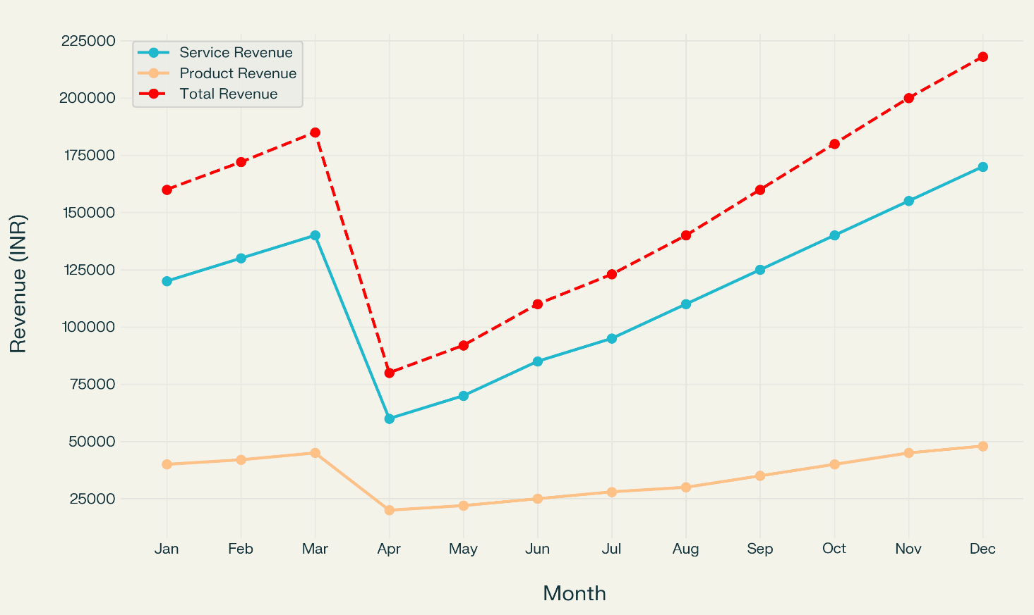

**Marginal Utility of Monthly Revenue - EduVibe AI**

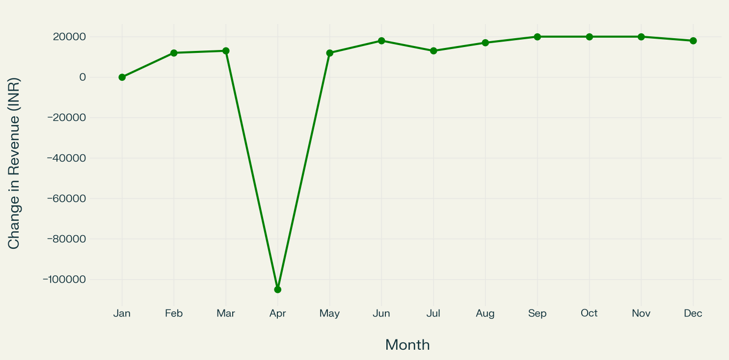

**Monthly Revenue Forecast (in INR) – EduVibe AI**

|  |  |  |  |
| --- | --- | --- | --- |
| **Month** | **Service Revenue** | **Product Revenue** | **Total Revenue** |
| Jan | ₹1,20,000 | ₹40,000 | ₹1,60,000 |
| Feb | ₹1,30,000 | ₹42,000 | ₹1,72,000 |
| Mar | ₹1,40,000 | ₹45,000 | ₹1,85,000 |
| Apr | ₹60,000 | ₹20,000 | ₹80,000 |
| May | ₹70,000 | ₹22,000 | ₹92,000 |
| Jun | ₹85,000 | ₹25,000 | ₹1,10,000 |
| Jul | ₹95,000 | ₹28,000 | ₹1,23,000 |
| Aug | ₹1,10,000 | ₹30,000 | ₹1,40,000 |
| Sep | ₹1,25,000 | ₹35,000 | ₹1,60,000 |
| Oct | ₹1,40,000 | ₹40,000 | ₹1,80,000 |
| Nov | ₹1,55,000 | ₹45,000 | ₹2,00,000 |
| Dec | ₹1,70,000 | ₹48,000 | ₹2,18,000 |

**12-Month Revenue Forecast Chart**

12-Month Revenue Forecast for EduVibe AI

* **Service Revenue**: Includes subscription fees and institutional licensing.
* **Product Revenue**: Includes add-on services such as mock interview packs.
* **Total Revenue**: Combined monthly total.

**Key Insights:**

* The forecast anticipates a seasonal dip in April and May, followed by steady growth as brand awareness and institutional partnerships increase.
* By year-end, total monthly revenue is projected to reach over ₹2 lakh, reflecting EduVibe AI’s expanding customer base and product adoption.

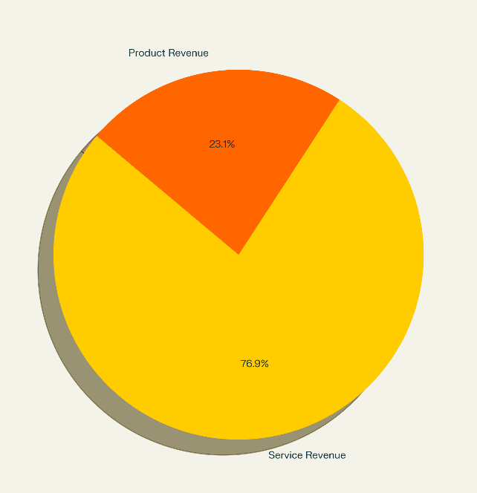

This pie chart illustrates the proportion of annual revenue contributed by service revenue (subscriptions, institutional licensing) versus product revenue (add-on services like mock interviews).

**14.Operational Plan**

**1. Product Development & Delivery**

* **Platform & AI Development:**  
  EduVibe AI’s core product is a cloud-based, AI-driven learning platform. The development process involves:
  + **AI Model Training:** Leveraging proprietary and open-source datasets for adaptive learning, mock interviews, and analytics.
  + **Content Creation:** In-house team and subject matter experts develop curriculum-aligned modules, assessments, and mock interview scripts.
  + **Software Stack:** Built using Python, React, and cloud infrastructure (AWS, Azure) for scalability and security.
  + **Quality Assurance:** Regular code reviews, automated testing, and user acceptance testing before feature rollouts.
* **Service Costing:**
  + **Per-user cloud/AI compute cost:** ~₹80/month
  + **Content licensing & royalties:** ~₹40/user/month
  + **Support & maintenance:** ~₹20/user/month
  + **Ongoing R&D:** Budgeted as a fixed monthly operational expense
* **Pricing:**
  + Standard plan: ₹499/month per user
  + Institutional license: ₹30,000/month per 100 students

**2. Quality Control**

* **Employee Training:**  
  All developers, content creators, and support staff undergo onboarding and continuous training in EdTech standards, data privacy, and AI ethics.
* **User Feedback Loops:**  
  Built-in platform feedback and ratings system; monthly NPS (Net Promoter Score) surveys for both students and institutional clients.
* **Content Review:**  
  All educational content is peer-reviewed and updated quarterly to meet curriculum and industry trends.
* **AI Model Monitoring:**  
  Continuous monitoring for accuracy, bias, and performance, with quarterly audits.

**3. Location**

* **Business Facility:**
  + Headquartered in Chennai, Tamil Nadu (1,200 sq. ft. co-working space in Tidel Park/OMR tech corridor).
  + Facility includes collaborative workspaces for tech, content, and support teams.
* **Rent & Utilities:**
  + Rent: ₹60,000/month
  + Utilities (internet, power, security): ₹15,000/month
* **Accessibility:**
  + Centrally located for easy access to tech talent, educational institutions, and partners.

**4. Legal Environment**

* **Business Registration:**  
  Registered as EduVibe AI Pvt. Ltd. under the Companies Act, India.
* **Licenses & Compliance:**
  + GSTIN and Professional Tax registration.
  + Compliance with India’s data protection laws and EdTech regulations.
* **Intellectual Property:**
  + Trademark filed for brand and logo.
  + Copyright for proprietary content and AI models.
* **Insurance:**
  + Professional liability and cyber risk insurance (₹10,00,000 per claim).

**5. Personnel**

* **Team Composition:**
  + 6 software engineers (₹60,000/month each)
  + 4 content developers (₹40,000/month each)
  + 2 AI/ML engineers (₹75,000/month each)
  + 2 customer support staff (₹30,000/month each)
  + 1 marketing manager (₹50,000/month)
  + 1 operations/admin manager (₹45,000/month)
* **Freelancers/Consultants:**  
  Engaged for specialized content or AI projects as needed (₹1,500 per module/interview set).
* **Recruitment Strategy:**  
  Hiring via LinkedIn, university placements, and industry referrals.
* **Training Cost:**  
  ₹1,00,000 annually for upskilling and compliance workshops.

**6. Inventory & IT Management**

* **Software Licenses:**  
  Annual investment in cloud services, security tools, and productivity software (~₹2,00,000/year).
* **Hardware:**  
  Laptops, servers, and backup devices for all team members.
* **Turnover Rate:**  
  Hardware replaced/upgraded every 3 years; software licenses reviewed annually.
* **Scalability:**  
  Cloud-based infrastructure allows instant scaling for user spikes (exam season, new partnerships).

**7. Suppliers & Partners**

* **Primary Suppliers:**
  + Cloud service providers (AWS, Azure)
  + EdTech content vendors for supplementary materials
* **Backup Suppliers:**
  + Alternate cloud providers and freelance content creators
* **Payment Terms:**
  + Monthly/quarterly payments with discounts for annual commitments
* **Risk Management:**
  + Multi-cloud strategy and regular data backups to minimize downtime

**8. Credit & Payment Policies**

* **Standard Terms:**
  + Monthly or annual payments for individual users
  + 30-day credit period for institutional clients
* **Creditworthiness:**
  + Institutional clients vetted via references and payment history
* **Delayed Payments:**
  + 2% late fee per month for overdue invoices
  + Reserve fund of ₹1,00,000 for potential bad debts

**9. Data Security & Compliance**

* **Data Protection:**  
  End-to-end encryption, regular security audits, and compliance with Indian and international privacy standards.
* **User Privacy:**  
  Transparent privacy policy and opt-in consent for data usage.
* **Regulatory Compliance:**  
  Adherence to state and national education and technology regulations.

EduVibe AI’s operational plan is designed for efficiency, scalability, and compliance. With a robust supplier network, skilled personnel, strong quality controls, and secure IT infrastructure, EduVibe AI is positioned for sustainable growth and long-term impact in the EdTech industry.

**15.Management and Organization**

**Organizational Hierarchy**

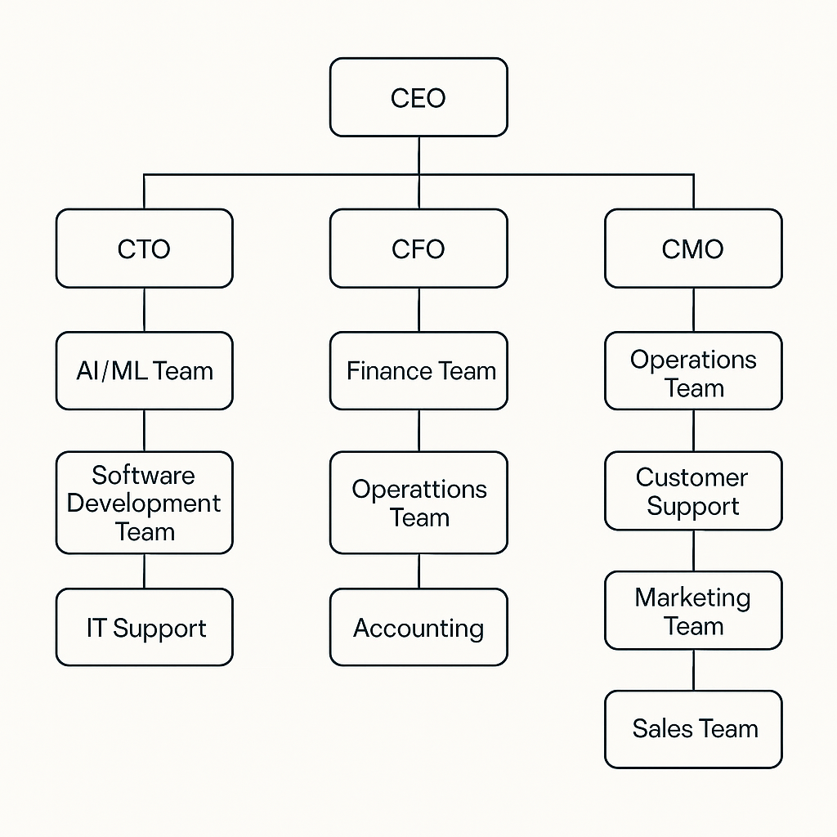

**Organizational Structure, Roles & Responsibilities, and Decision-Making Process – EduVibe AI**

**Hierarchical Breakdown**

**1. Chief Executive Officer (CEO)**

* Sets the overall vision, strategic goals, and company culture.
* Makes final decisions on expansion, investments, and key partnerships.
* Oversees all C-level executives (CTO, CFO, CMO) and ensures alignment across departments.

**2. Chief Technology Officer (CTO)**

* Leads the AI/ML Team, Software Development Team, and IT Support.
* Responsible for the platform’s technical architecture, security, and innovation.
* Oversees product roadmap, feature rollouts, and technology partnerships.

**3. Chief Financial Officer (CFO)**

* Heads the Finance Team, Operations Team, and Accounting.
* Manages budgeting, financial planning, audits, and compliance.
* Approves major expenditures and tracks financial KPIs.

**4. Chief Marketing Officer (CMO)**

* Directs the Operations Team, Customer Support, Marketing Team, and Sales Team.
* Develops and implements branding, digital marketing, and customer acquisition strategies.
* Oversees public relations, partnerships, and market research.

**Departmental Heads & Mid-Level Management**

* **AI/ML Team Lead:** Manages AI model development, data analysis, and integration with the learning platform.
* **Software Development Manager:** Oversees coding, testing, and deployment of new features.
* **IT Support Lead:** Ensures platform uptime, cybersecurity, and technical support for staff.
* **Finance Manager:** Handles day-to-day financial transactions, payroll, and reporting.
* **Operations Manager:** Coordinates internal processes, resource allocation, and project management.
* **Accounting Lead:** Manages invoicing, compliance, and tax filings.
* **Marketing Manager:** Runs campaigns, content creation, and digital outreach.
* **Sales Head:** Directs the sales team, sets targets, and manages client relationships.
* **Customer Support Manager:** Ensures high-quality user support, manages feedback, and oversees training for support staff.

**Roles & Responsibilities**

|  |  |
| --- | --- |
| **Role/Dept.** | **Key Responsibilities** |
| CEO | Vision, strategy, final decision-making, investor relations, company culture |
| CTO | Tech innovation, product roadmap, AI/ML development, cybersecurity, IT infrastructure |
| CFO | Budgeting, financial planning, audits, compliance, financial risk management |
| CMO | Branding, digital marketing, PR, sales growth, customer engagement, partnerships |
| AI/ML Team | AI model training, data analysis, algorithm optimization |
| Software Development Team | Platform coding, feature development, QA, bug fixes |
| IT Support | Platform uptime, cybersecurity, technical troubleshooting |
| Finance Team | Daily transactions, payroll, financial reporting |
| Operations Team | Project management, resource allocation, process optimization |
| Accounting | Invoicing, tax compliance, audit support |
| Marketing Team | Campaign execution, social media, content, analytics |
| Sales Team | Client acquisition, lead conversion, partnerships |
| Customer Support | User assistance, feedback management, onboarding, training |

**Flow of Power & Decision-Making Process**

1. **CEO** sets overall company goals and communicates strategy to CTO, CFO, and CMO.
2. **CTO** leads all technology and product-related decisions, including AI/ML, software, and IT.
3. **CFO** manages all financial decisions, budget approvals, and compliance.
4. **CMO** oversees marketing, customer support, and sales strategies.
5. **Departmental Heads** (e.g., AI/ML Lead, Marketing Manager) make operational decisions within their teams and report to their respective C-level executive.
6. **Mid-Level Managers** implement strategies, manage staff, and report progress and issues upwards.
7. **Staff** execute daily tasks and provide feedback for process improvement.
8. **Strategic Decisions** (expansion, pricing, major investments) are made by the CEO, with input from the CTO and CFO.
9. **Operational Decisions** (feature releases, campaign launches, hiring) are managed by department heads.
10. **Feedback Loop:** Employee and user feedback is regularly collected and considered in process and product improvements.

**Decision-Making Hierarchy Table**

|  |  |
| --- | --- |
| **Decision Type** | **Responsible Authority** |
| Product Roadmap | CTO & AI/ML Lead |
| Pricing Strategy | CEO & CFO |
| Marketing Budget | CMO & Finance Manager |
| IT Security | CTO & IT Support Lead |
| Customer Policies | CMO & Customer Support Manager |
| Financial Compliance | CFO & Accounting Lead |
| Employee Policies | Operations Manager & CEO |

**Organizational Culture & Values**

* **Innovation:** Commitment to continuous improvement in AI and learning technology.
* **Integrity:** Transparent business practices and ethical use of data.
* **Customer-Centricity:** Focus on user satisfaction and educational impact.
* **Collaboration:** Open communication and teamwork across all levels.
* **Growth:** Ongoing training, mentorship, and career advancement for employees.

**Performance Evaluation & Promotion Structure**

* **KPIs for Each Role:**
  + AI/ML: Model accuracy, deployment speed, innovation
  + Marketing: Campaign ROI, user acquisition, engagement rates
  + Sales: Monthly targets, conversion rates, client retention
  + Customer Support: Satisfaction ratings, resolution time
* **Promotion Policy:**
  + High performers and those demonstrating leadership potential are prioritized for advancement.
  + Regular training and mentorship programs prepare staff for higher responsibilities.

**Training & Development**

* **New Employee Onboarding:** Structured 2-week program covering company systems, data privacy, and customer engagement.
* **Monthly Workshops:** Led by internal or guest experts on AI, EdTech trends, and soft skills.
* **Annual Certifications:** Encouraged in AI, data security, and digital marketing.

**Crisis Management Plan**

|  |  |
| --- | --- |
| **Crisis Type** | **Mitigation Plan** |
| Financial Downturn | Maintain reserves, reduce discretionary spending |
| IT/Data Breach | Regular security audits, incident response team |
| Talent Attrition | Succession planning, cross-training, retention incentives |
| Regulatory Changes | Ongoing compliance monitoring, legal advisors |

**Advisory Team**

* **Legal Advisor:** Ensures compliance with corporate, labor, and data protection laws.
* **Accountant:** Manages tax filings, audits, and financial planning.
* **Industry Consultants:** Provide insights on EdTech trends and operational best practices.
* **Banking Partner:** Supports cash flow management and funding.

EduVibe AI’s organizational structure is designed for agility, innovation, and customer focus. Clear roles, robust decision-making processes, and a culture of continuous learning empower the company to scale efficiently and adapt to the dynamic EdTech market.

**16.Startup Expenses and Capitalization**

**1. Start-up expenses**

|  |  |  |
| --- | --- | --- |
| **Category** | **Amount (INR)** | **Notes** |
| Company Registration & Legal Fees | ₹ 12,000 | MCA + PAN + Trademark |
| Domain & Hosting (1 Year) | ₹ 3,000 | GoDaddy + Shared Hosting |
| Software Licenses (Premium Tools) | ₹ 15,000 | Canva Pro, Notion, Zoom Pro, etc. |
| Branding & Digital Marketing | ₹ 40,000 | Initial campaigns + Logo + Content creation |
| Equipment (Laptops x 2) | ₹ 120,000 | Mid-range laptops (₹60K each) |
| Co-working/Shared Space (3 month) | ₹ 18,000 | ₹6,000/month in Tier-2/3 city |
| Salaries (3 Members × ₹15K × 3 month) | ₹ 135,000 | Reasonable stipend/fresher pay |
| Miscellaneous | ₹ 17,000 | Travel, Utilities, Unexpected |
| **Total Start-Up Expenses** | **₹ 360,000** |  |
| **2.Opening Day Balance Sheet** |
| **Asset** |  |
| **Asset** | **Amount (INR)** |
| Cash in Bank | ₹ 120,000 |
| Equipment (Laptops) | ₹ 120,000 |
| Prepaid Hosting/Tools | ₹ 18,000 |
| Advance Co-working Rent | ₹ 12,000 |
| Marketing Collateral | ₹ 90,000 |
| **Total Assets** | **₹ 360,000** |
| **Liability** |  |
| **Item** | **Amount (INR)** |
| Founder’s Equity | ₹ 250,000 |
| Angel/Family Loan (0% Interest) | ₹ 110,000 |
| **Total Liabilities & Capital** | **₹ 360,000** |

**3.Personal Financial Statement**

|  |  |
| --- | --- |
| **Assets** | **Amount (INR)** |
| Savings | ₹ 100,000 |
| Fixed Deposit | ₹ 80,000 |
| Laptop (Owned) | ₹ 50,000 |
| **Total Assets** | **₹ 230,000** |
|  |  |
| **Liabilities** | **Amount (INR)** |
| Education Loan Balance | ₹ 40,000 |
| Credit Card Due | ₹ 10,000 |
| **Total Liabilities** | **₹ 50,000** |

**17.Financial Plan**

**12-Month Profit & Loss Projection**

|  |  |
| --- | --- |
| **Item** | **Amount (INR)** |
| **Revenue** |  |
| B2C Subscriptions | ₹ 300,000 |
| B2B Licensing (3 clients) | ₹ 180,000 |
| Workshops & Events | ₹ 40,000 |
| **Total Revenue** | **₹ 520,000** |
|  |  |
| **Expenses** |  |
| Salaries (₹15K×3×12) | ₹ 540,000 |
| Hosting & SaaS Tools | ₹ 18,000 |
| Marketing & Branding | ₹ 72,000 |
| Utilities & Travel | ₹ 48,000 |
| Maintenance & Misc. | ₹ 12,000 |
| **Total Expenses** | **₹ 690,000** |
|  |  |
| **Net Profit/Loss (Year 1)** | **₹ -170,000** |

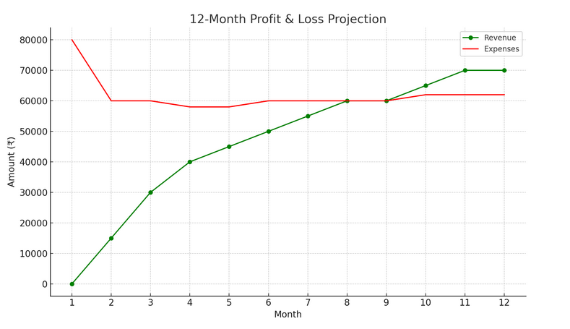

**3-year profit & Loss projection**

|  |  |  |  |
| --- | --- | --- | --- |
| **Year** | **Revenue (INR)** | **Expenses (INR)** | **Net Profit/Loss** |
| Year 1 | ₹ 520,000 | ₹ 690,000 | **₹ -170,000** |
| Year 2 | ₹ 900,000 | ₹ 720,000 | ₹ 180,000 |
| Year 3 | ₹ 1,400,000 | ₹ 900,000 | ₹ 500,000 |

**Cash Flow Projection (12 Months)**

|  |  |  |  |  |
| --- | --- | --- | --- | --- |
| **Month** | **Inflow (₹)** | **Outflow (₹)** | **Net Cash Flow (₹)** | **Cumulative Balance** |
| Month 1 | ₹ 0 | ₹ 80,000 | ₹ -80,000 | ₹ -80,000 |
| Month 2 | ₹ 15,000 | ₹ 60,000 | ₹ -45,000 | ₹ -125,000 |
| Month 3 | ₹ 30,000 | ₹ 60,000 | ₹ -30,000 | ₹ -155,000 |
| Month 4 | ₹ 40,000 | ₹ 58,000 | ₹ -18,000 | ₹ -173,000 |
| Month 5 | ₹ 45,000 | ₹ 58,000 | ₹ -13,000 | ₹ -186,000 |
| Month 6 | ₹ 50,000 | ₹ 60,000 | ₹ -10,000 | ₹ -196,000 |
| Month 7 | ₹ 55,000 | ₹ 60,000 | ₹ -5,000 | ₹ -201,000 |
| Month 8 | ₹ 60,000 | ₹ 60,000 | ₹ 0 | ₹ -201,000 |
| Month 9 | ₹ 60,000 | ₹ 60,000 | ₹ 0 | ₹ -201,000 |
| Month 10 | ₹ 65,000 | ₹ 62,000 | ₹ 3,000 | ₹ -198,000 |
| Month 11 | ₹ 70,000 | ₹ 62,000 | ₹ 8,000 | ₹ -190,000 |
| Month 12 | ₹ 70,000 | ₹ 62,000 | ₹ 8,000 | ₹ -182,000 |

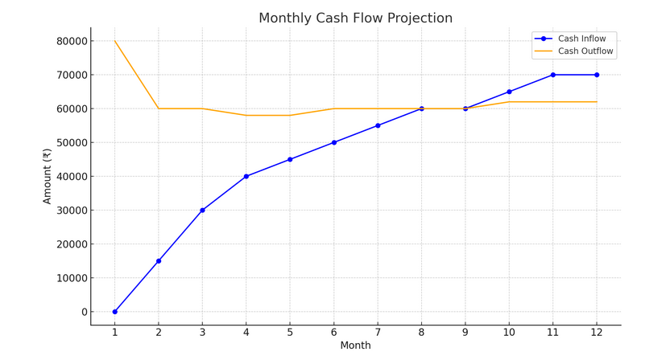

**3-Year Cash Flow Statement**

|  |  |  |  |
| --- | --- | --- | --- |
| **Year** | **Total Inflow** | **Total Outflow** | **Net Cash Flow** |
| Year 1 | ₹ 560,000 | ₹ 742,000 | ₹ -182,000 |
| Year 2 | ₹ 900,000 | ₹ 720,000 | ₹ 180,000 |
| Year 3 | ₹ 1,400,000 | ₹ 900,000 | ₹ 500,000 |

**Projected Balance Sheet**

|  |  |
| --- | --- |
| **Category** | **Amount (₹)** |
| **Assets** |  |
| Cash in Bank | 318,000 |
| Equipment & Infrastructure | 100,000 |
| Office Setup & Miscellaneous | 50,000 |
| **Total Assets** | 468,000 |
|  |  |
|  |  |
| **Liabilities** | **Amount (INR)** |
| Founder Capital | ₹ 250,000 |
| Retained Earnings (Net Loss) | –1,82,000 |
| Total Liabilities & Equity | 3,18,000 |

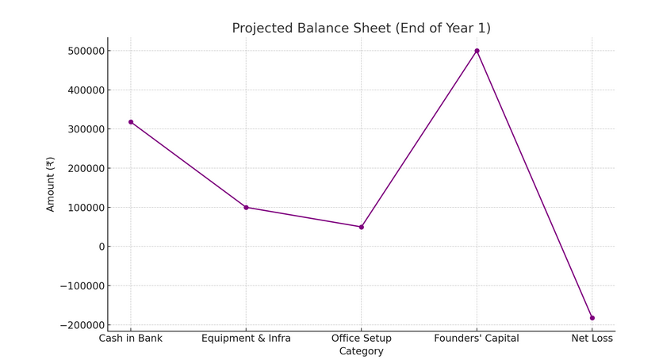 **18.Appendices**.

**Legal & Operational Documents**

Essential agreements and compliance materials for EduVibe AI’s operations:

* **Registered Office Lease Agreement**: For co-working space in Chennai’s OMR tech corridor.
* **Cloud Service Agreements**: Contracts with AWS/Azure for scalable infrastructure.
* **Institutional Partnership MOUs**: Letters of Intent from 10+ schools and colleges for platform trials.
* **Employment Contracts**: For full-time staff (developers, content creators, support team).
* **Vendor Agreements**: With AI tool providers (e.g., OpenAI API, Google Cloud AI).

**Intellectual Property & Certifications**

* **Trademark Registration**: "EduVibe AI" name and logo (application pending).
* **Business Licenses**: GST registration, MSME certification.
* **Compliance Documents**:
  + Data Protection Policy (aligned with India’s PDP Bill).
  + ISO 27001 certification for cybersecurity (in progress).
  + Educational Content Copyrights for proprietary courses.

**Team Profiles**

Resumes of key personnel:

* **CEO**: 10+ years in EdTech, led AI-driven learning projects.
* **CTO**: PhD in Machine Learning, ex-lead at a top EdTech firm.
* **CMO**: Digital marketing expert with EdTech campaign success.
* **CFO**: Chartered Accountant with SaaS startup experience.
* **Advisory Board**: Includes IIT Madras professors and AI ethics experts.

**Branding & Marketing Collateral**

* **Brand Guidelines**: Color palette (academic blue/white), typography, tone (trustworthy yet innovative).
* **Digital Assets**:
  + Website screenshots and mobile app prototypes.
  + Social media creatives (Instagram/YouTube shorts for student engagement).
  + Demo video of AI mock interviews.
* **Print Materials**: Brochures for institutional partnerships.

**Media & Public Relations Resources**

* **Press Release**: "EduVibe AI Launches to Bridge the Skills Gap with Adaptive Learning."
* **PR Strategy**: Targeting education journals (Education Times, EdTech Review) and tech media.
* **Success Stories**: Case studies of beta users (e.g., "Student Lands FAANG Job via EduVibe AI").
* **Event Plans**: Participation in EdTech summits (e.g., India Didac) and AI conferences.

**Layouts & Visual Plans**

* **Platform Architecture**: Flowchart of AI-driven learning pathways and data integration.
* **User Journey Map**: From sign-up to skill mastery.
* **Office Layout**: Shared workspace design for hybrid teams.

**Equipment Inventory**

|  |  |  |
| --- | --- | --- |
| **Item** | **Quantity** | **Value (INR)** |
| Laptops (Development) | 5 | ₹300,000 |
| Cloud Server Credits | Annual | ₹200,000 |
| Software Licenses | 10 | ₹150,000 |
| AI Training Hardware | 2 GPUs | ₹500,000 |

**Market Research Insights**

* **Industry Report**: "AI in Indian Education to Grow at 30% CAGR by 2030."
* **Competitor Benchmarking**: Feature comparison with BYJU’S, Unacademy, and global peers.
* **Customer Surveys**: 85% of students demand personalized career-prep tools.
* **SWOT Analysis**: Highlights EduVibe’s AI edge and challenges in rural digital literacy.

**Business Assets for Collateral**

This appendix provides stakeholders with a holistic view of EduVibe AI’s readiness, compliance, and strategic assets, reinforcing its position as a scalable, innovative EdTech solution.

|  |  |
| --- | --- |
| **Asset** | **Value (INR)** |
| Proprietary AI Algorithms | ₹5,00,000 (IP) |
| Platform Codebase | ₹10,00,000 |
| Office Equipment | ₹2,00,000 |
| Customer Database | ₹3,00,000 |

**19. Corporate Social Responsibility(CSR)**

**CSR Policy Statement**

EduVibe AI is committed to fostering inclusive, ethical, and sustainable educational growth. Our CSR framework is built on four pillars:

* **Educational Empowerment**
* **Digital Inclusion**
* **Ethical Responsibility**
* **Community Engagement**

We strive to bridge the digital divide, promote lifelong learning, and contribute to the holistic development of underserved communities through technology-driven education.

**CSR Objectives**

1. Expand access to quality education for marginalized and rural students.
2. Promote digital literacy and responsible AI usage.
3. Support teacher training and upskilling for under-resourced schools.
4. Empower communities through educational outreach and scholarships.

**CSR Initiatives Calendar (Annual Plan)**

|  |  |  |  |  |
| --- | --- | --- | --- | --- |
| **Quarter** | **Initiative** | **Description** | **Target Beneficiaries** | **Frequency** |
| Q1 | Free Digital Learning Camps | Free AI-powered workshops for students in rural schools | 200+ Rural Students | Monthly |
| Q1 | Teacher Upskilling Workshops | Training sessions on digital tools and pedagogy | 50+ Teachers | Quarterly |
| Q2 | Digital Scholarship Program | Scholarships for underprivileged students to access EduVibe AI | 30 Students | Once Annually |
| Q2 | NGO Partnership Drive | Collaborate with NGOs for digital literacy campaigns | Partner NGOs | Twice Annually |
| Q3 | Community Coding Drive | Coding bootcamps for school children in urban slums | 100+ Students | Once Annually |
| Q3 | Employee Volunteering | Staff-led mentoring and career guidance sessions | Local Communities | Twice Annually |
| Q4 | AI Ethics Awareness Campaign | Online campaigns on safe and ethical AI use | Students, Parents, Teachers | Continuous |
| Q4 | CSR Fund Donation | Donations to education-focused NGOs and digital libraries | NGOs/CSR Partners | Annual |

**CSR Budget Allocation Plan (Estimated)**

|  |  |
| --- | --- |
| **Activity/Initiative** | **Annual Budget (INR)** |
| Free Digital Learning Camps | ₹60,000 |
| Teacher Upskilling Workshops | ₹40,000 |
| Digital Scholarship Program | ₹50,000 |
| NGO Partnership & Donations | ₹40,000 |
| Community Coding Drive | ₹20,000 |
| Employee Volunteering Activities | ₹10,000 |
| AI Ethics Awareness Campaign | ₹15,000 |
| CSR Communication & Reporting | ₹15,000 |
| **Total Annual CSR Budget** | **₹2,50,000** |

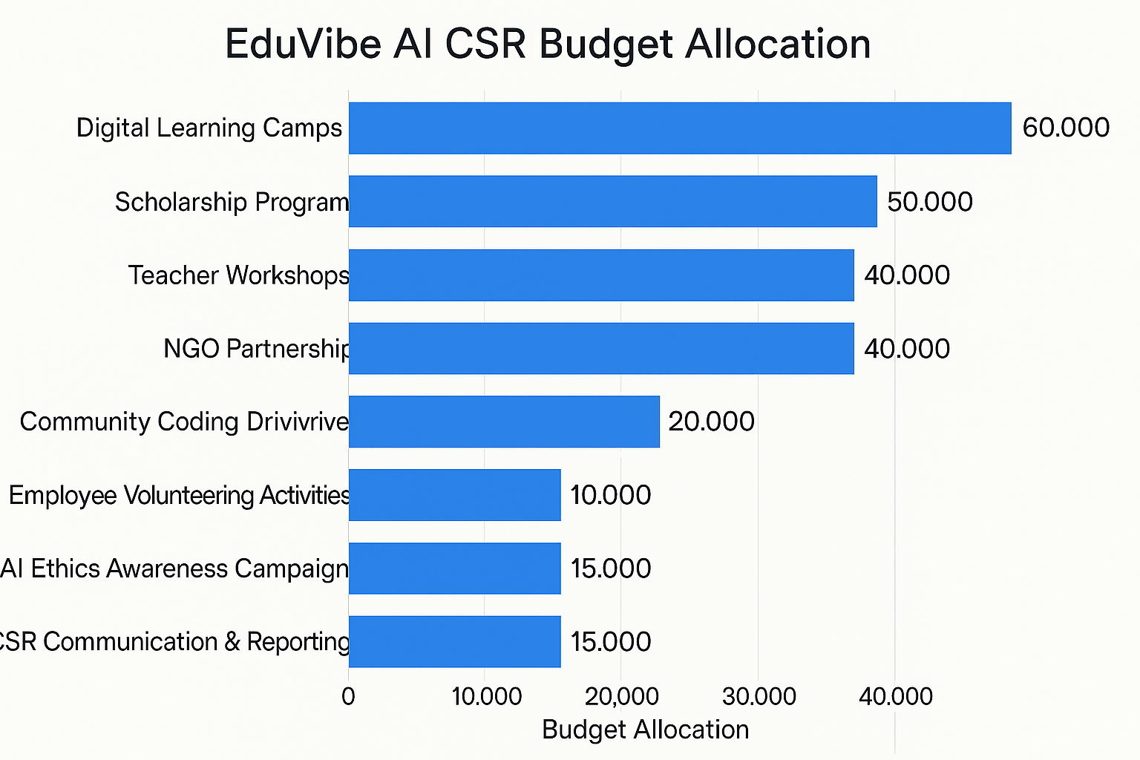

**Monitoring & Evaluation**

* **Annual CSR Impact Report** prepared by the CSR Committee.
* Regular feedback from beneficiaries, teachers, and partners.
* Tracking of employee participation in volunteering and outreach.
* Transparent financial tracking of CSR fund utilization.

**Governance**

CSR implementation will be overseen by the EduVibe AI CSR Committee, comprising:

* Founder & CEO
* CTO
* HR Manager
* Marketing Manager
* External CSR Advisor (as needed)

**Reporting**

All CSR activities and expenditures will be documented and published in the EduVibe AI Annual Report for transparency and stakeholder communication.

EduVibe AI’s CSR initiatives are designed to create lasting educational impact, promote digital inclusion, and empower communities through technology and innovation.

**20.Conclusion**

EduVibe AI represents the future of education technology-a transformative platform built at the intersection of artificial intelligence, personalized learning, and career readiness. At a time when traditional education struggles to meet individual learning needs and prepare students for an increasingly competitive job market, EduVibe AI offers an innovative solution that not only addresses these challenges but also democratizes access to quality education.

Our AI-driven adaptive learning platform challenges conventional educational approaches by providing truly personalized experiences tailored to each learner's unique pace, style, and goals. By integrating cutting-edge technology with pedagogical expertise, we've created a comprehensive ecosystem that supports students, professionals, and educators throughout their educational journeys. The platform's standout feature-AI-powered mock interviews-bridges the critical gap between academic learning and professional success, equipping users with the practical skills and confidence needed to excel in real-world scenarios.

The operational model is scalable, digitally-focused, and designed for accessibility-allowing EduVibe AI to reach learners across urban and rural India through our mobile-first approach and multilingual support. With tiered pricing strategies catering to both individual users and institutional clients, we ensure our platform remains affordable while maintaining a path to profitability and growth.

Beyond business objectives, EduVibe AI remains deeply committed to social impact through our comprehensive CSR initiatives. Our programs focus on digital literacy, educational empowerment for underserved communities, teacher training, and ethical AI awareness-reflecting our vision of building a business that balances innovation with inclusion and responsibility.

As we look ahead, our goals are clear-to enhance our AI capabilities, expand our content library, strengthen institutional partnerships, and continuously improve user experiences to stay at the forefront of EdTech innovation. With a strong technological foundation, a passionate team, and a learner-centric approach, EduVibe AI is well-positioned to lead the educational transformation in India and beyond.

We invite partners, investors, and educational stakeholders to join us in advancing this vision-to not just deliver content, but to create personalized learning journeys, bridge educational divides, empower career aspirations, and build a more equitable future through the power of AI-enhanced education.